MANUAL HYPERPARAMETER SELECTION FORM
2D CNN Model — Dogs vs. Cats Image Classification
Name: Mark Bryan C. Tenebroso
Program: DENG - CpE
Use this form to record, justify, and approve each hyperparameter value chosen by hand before a training run. The "Notebook Default" column shows the value currently used in Loading_Dataset_and_CNN.ipynb for reference — enter the value actually used for this run under "Chosen Value", even if it matches the default.

1. Project / Experiment Information
Project / Experiment Title
Model Architecture | 2D Convolutional Neural Network (Conv2D)
Dataset Used | Kaggle Dogs vs. Cats images (Dog/ and Cat/ folders)
Notebook / File Reference | Loading_Dataset_and_CNN.ipynb
Prepared By | Mark Bryan C. Tenebroso
Date | 9/27/2026
Experiment / Trial No.

2. Data Preprocessing Parameters
Hyperparameter | Options / Range Considered | Notebook Default | Chosen Value | Justification
Image Size (IMG_SIZE, square) | e.g. 50 / 80 / 100 / 128 / 150 | 100 | 100 | Retains standard spatial resolution suitable for cats vs. dogs classification while keeping memory overhead and training time per epoch manageable.
Color Mode | Grayscale / RGB | Grayscale | RGB | Switching to 3-channel RGB preserves color cues necessary for improved feature discrimination over grayscale.
Pixel Normalization | X/255.0 / none | X/255.0 | X/255.0 | Scales integer pixel values from $\left[0,255\right]$ down to $\left[0.0,1.0\right]$, preventing exploding gradients and enabling stable Adam optimization.
Shuffle Training Data | Yes / No | Yes (random.shuffle) | Yes | Prevents class ordering bias (e.g., all Dogs followed by all Cats) during mini-batch gradient updates.
Held-out Test Set (separate from training) | Yes / No | No (validation_split only) | No | Follows the original notebook's evaluation pipeline using an in-memory validation split.
Validation Split (of training set) | 0.0 - 0.3 | 0.1 | 0.2 | Increasing the split to 0.2 (20%) provides a larger, more statistically reliable validation set to track potential overfitting and evaluate generalization performance.

3. Model Architecture Hyperparameters
Trial 1
Hyperparameter | Options / Range Considered | Notebook Default | Chosen Value | Justification | Training Accuracy | Validation Accuracy
Conv2D Layer 1 – Filters | 16 / 32 / 64 / 128 | 14 | 8 – 64 – 128  1st – 2nd – 3rd Layer | Started at low value | 90.68 | 81.58
Conv2D Layer 1 – Kernel Size | (3,3) / (5,5) | (3,3) | (3,3) | Standard local receptive field that effectively captures fine spatial details while keeping the parameter count low. | 90.68 | 81.58
Conv2D Layer 1 – Activation | relu / tanh / elu / leaky_relu | relu | relu | Standard non-linear activation that reduces vanishing gradient issues during backpropagation and keeps computation efficient. | 90.68 | 81.58
Pooling Layer 1 – Type & Pool Size | MaxPooling2D / AveragePooling2D; (2,2) / (3,3) | MaxPooling2D, (2,2) | MaxPooling2D, (2,2) | Downsamples spatial dimensions by half ($100 \times 100 \rightarrow 50 \times 50$) while retaining sharp, dominant feature signals. | 90.68 | 81.58
Dense (Fully Connected) Units | 16 / 32 / 64 / 128 | 64 | 64 | Bottlenecks the flattened feature vectors into a high-level representation before binary classification. | 90.68 | 81.58
Dropout Rate | 0.0 - 0.5 | None (not used) | 0.5 | Regularizes the dense connections to prevent node co-adaptation and address the overfitting observed in early epochs. | 90.68 | 81.58
Output Layer Activation | sigmoid (binary) / softmax (multi-class) | sigmoid | sigmoid | Standard activation for single-neuron binary classification (Cat vs. Dog), outputting a probability between $0.0$ and $1.0$. | 90.68 | 81.58

Trial 2
Hyperparameter | Options / Range Considered | Notebook Default | Chosen Value | Justification | Training Accuracy | Validation Accuracy
Conv2D Layer 1 – Filters | 16 / 32 / 64 / 128 | 14 | 16 – 64 - 128 | Started at low value | 91.73 | 83.40
Conv2D Layer 1 – Kernel Size | (3,3) / (5,5) | (3,3) | (3,3) | Standard local receptive field that effectively captures fine spatial details while keeping the parameter count low. | 91.73 | 83.40
Conv2D Layer 1 – Activation | relu / tanh / elu / leaky_relu | relu | relu | Standard non-linear activation that reduces vanishing gradient issues during backpropagation and keeps computation efficient. | 91.73 | 83.40
Pooling Layer 1 – Type & Pool Size | MaxPooling2D / AveragePooling2D; (2,2) / (3,3) | MaxPooling2D, (2,2) | MaxPooling2D, (2,2) | Downsamples spatial dimensions by half ($100 \times 100 \rightarrow 50 \times 50$) while retaining sharp, dominant feature signals. | 91.73 | 83.40
Dense (Fully Connected) Units | 16 / 32 / 64 / 128 | 64 | 64 | Bottlenecks the flattened feature vectors into a high-level representation before binary classification. | 91.73 | 83.40
Dropout Rate | 0.0 - 0.5 | None (not used) | 0.5 | Regularizes the dense connections to prevent node co-adaptation and address the overfitting observed in early epochs. | 91.73 | 83.40
Output Layer Activation | sigmoid (binary) / softmax (multi-class) | sigmoid | sigmoid | Standard activation for single-neuron binary classification (Cat vs. Dog), outputting a probability between $0.0$ and $1.0$. | 91.73 | 83.40

Trial 3
Hyperparameter | Options / Range Considered | Notebook Default | Chosen Value | Justification | Training Accuracy | Validation Accuracy
Conv2D Layer 1 – Filters | 16 / 32 / 64 / 128 | 14 | 32 – 64 - 128 | Started at low value | 91.31 | 84.70
Conv2D Layer 1 – Kernel Size | (3,3) / (5,5) | (3,3) | (3,3) | Standard local receptive field that effectively captures fine spatial details while keeping the parameter count low. | 91.31 | 84.70
Conv2D Layer 1 – Activation | relu / tanh / elu / leaky_relu | relu | relu | Standard non-linear activation that reduces vanishing gradient issues during backpropagation and keeps computation efficient. | 91.31 | 84.70
Pooling Layer 1 – Type & Pool Size | MaxPooling2D / AveragePooling2D; (2,2) / (3,3) | MaxPooling2D, (2,2) | MaxPooling2D, (2,2) | Downsamples spatial dimensions by half ($100 \times 100 \rightarrow 50 \times 50$) while retaining sharp, dominant feature signals. | 91.31 | 84.70
Dense (Fully Connected) Units | 16 / 32 / 64 / 128 | 64 | 64 | Bottlenecks the flattened feature vectors into a high-level representation before binary classification. | 91.31 | 84.70
Dropout Rate | 0.0 - 0.5 | None (not used) | 0.5 | Regularizes the dense connections to prevent node co-adaptation and address the overfitting observed in early epochs. | 91.31 | 84.70
Output Layer Activation | sigmoid (binary) / softmax (multi-class) | sigmoid | sigmoid |  | 91.31 | 84.70

Trial 4
Hyperparameter | Options / Range Considered | Notebook Default | Chosen Value | Justification | Training Accuracy | Validation Accuracy
Conv2D Layer 1 – Filters | 16 / 32 / 64 / 128 | 14 | 16 – 32 - 128 | Started at low value | 91.06 | 83.18
Conv2D Layer 1 – Kernel Size | (3,3) / (5,5) | (3,3) | (3,3) |  | 91.06 | 83.18
Conv2D Layer 1 – Activation | relu / tanh / elu / leaky_relu | relu | relu |  | 91.06 | 83.18
Pooling Layer 1 – Type & Pool Size | MaxPooling2D / AveragePooling2D; (2,2) / (3,3) | MaxPooling2D, (2,2) | MaxPooling2D, (2,2) |  | 91.06 | 83.18
Dense (Fully Connected) Units | 16 / 32 / 64 / 128 | 64 | 64 |  | 91.06 | 83.18
Dropout Rate | 0.0 - 0.5 | None (not used) | 0.5 |  | 91.06 | 83.18
Output Layer Activation | sigmoid (binary) / softmax (multi-class) | sigmoid | sigmoid |  | 91.06 | 83.18

Trial 5
Hyperparameter | Options / Range Considered | Notebook Default | Chosen Value | Justification | Training Accuracy | Validation Accuracy
Conv2D Layer 1 – Filters | 16 / 32 / 64 / 128 | 14 | 16 – 128 - 128 | Started at low value | 91.18 | 81.06
Conv2D Layer 1 – Kernel Size | (3,3) / (5,5) | (3,3) | (3,3) |  | 91.18 | 81.06
Conv2D Layer 1 – Activation | relu / tanh / elu / leaky_relu | relu | relu |  | 91.18 | 81.06
Pooling Layer 1 – Type & Pool Size | MaxPooling2D / AveragePooling2D; (2,2) / (3,3) | MaxPooling2D, (2,2) | MaxPooling2D, (2,2) |  | 91.18 | 81.06
Dense (Fully Connected) Units | 16 / 32 / 64 / 128 | 64 | 64 |  | 91.18 | 81.06
Dropout Rate | 0.0 - 0.5 | None (not used) | 0.5 |  | 91.18 | 81.06
Output Layer Activation | sigmoid (binary) / softmax (multi-class) | sigmoid | sigmoid |  | 91.18 | 81.06
Trial 6
Hyperparameter | Options / Range Considered | Notebook Default | Chosen Value | Justification | Training Accuracy | Validation Accuracy
Conv2D Layer 1 – Filters | 16 / 32 / 64 / 128 | 14 | 16 - 128 | Tried 2 CNN only | 89.09 | 80.70
Conv2D Layer 1 – Kernel Size | (3,3) / (5,5) | (3,3) | (3,3) |  | 89.09 | 80.70
Conv2D Layer 1 – Activation | relu / tanh / elu / leaky_relu | relu | relu |  | 89.09 | 80.70
Pooling Layer 1 – Type & Pool Size | MaxPooling2D / AveragePooling2D; (2,2) / (3,3) | MaxPooling2D, (2,2) | MaxPooling2D, (2,2) |  | 89.09 | 80.70
Dense (Fully Connected) Units | 16 / 32 / 64 / 128 | 64 | 64 |  | 89.09 | 80.70
Dropout Rate | 0.0 - 0.5 | None (not used) | 0.5 |  | 89.09 | 80.70
Output Layer Activation | sigmoid (binary) / softmax (multi-class) | sigmoid | sigmoid |  | 89.09 | 80.70

Trial 7
Hyperparameter | Options / Range Considered | Notebook Default | Chosen Value | Justification | Training Accuracy | Validation Accuracy
Conv2D Layer 1 – Filters | 16 / 32 / 64 / 128 | 14 | 16 - 64 - 64 |  | 90.81 | 84.94
Conv2D Layer 1 – Kernel Size | (3,3) / (5,5) | (3,3) | (3,3) |  | 90.81 | 84.94
Conv2D Layer 1 – Activation | relu / tanh / elu / leaky_relu | relu | relu |  | 90.81 | 84.94
Pooling Layer 1 – Type & Pool Size | MaxPooling2D / AveragePooling2D; (2,2) / (3,3) | MaxPooling2D, (2,2) | MaxPooling2D, (2,2) |  | 90.81 | 84.94
Dense (Fully Connected) Units | 16 / 32 / 64 / 128 | 64 | 64 |  | 90.81 | 84.94
Dropout Rate | 0.0 - 0.5 | None (not used) | 0.5 |  | 90.81 | 84.94
Output Layer Activation | sigmoid (binary) / softmax (multi-class) | sigmoid | sigmoid |  | 90.81 | 84.94
Trial 8
Hyperparameter | Options / Range Considered | Notebook Default | Chosen Value | Justification | Training Accuracy | Validation Accuracy
Conv2D Layer 1 – Filters | 16 / 32 / 64 / 128 | 14 | 20 - 64 - 128 |  | 92.16 | 84.82
Conv2D Layer 1 – Kernel Size | (3,3) / (5,5) | (3,3) | (3,3) |  | 92.16 | 84.82
Conv2D Layer 1 – Activation | relu / tanh / elu / leaky_relu | relu | relu |  | 92.16 | 84.82
Pooling Layer 1 – Type & Pool Size | MaxPooling2D / AveragePooling2D; (2,2) / (3,3) | MaxPooling2D, (2,2) | MaxPooling2D, (2,2) |  | 92.16 | 84.82
Dense (Fully Connected) Units | 16 / 32 / 64 / 128 | 64 | 64 |  | 92.16 | 84.82
Dropout Rate | 0.0 - 0.5 | None (not used) | 0.5 |  | 92.16 | 84.82
Output Layer Activation | sigmoid (binary) / softmax (multi-class) | sigmoid | sigmoid |  | 92.16 | 84.82

Trial 9
Hyperparameter | Options / Range Considered | Notebook Default | Chosen Value | Justification | Training Accuracy | Validation Accuracy
Conv2D Layer 1 – Filters | 16 / 32 / 64 / 128 | 14 | 25 - 64 - 128 |  | 93.28 | 86.34
Conv2D Layer 1 – Kernel Size | (3,3) / (5,5) | (3,3) | (3,3) |  | 93.28 | 86.34
Conv2D Layer 1 – Activation | relu / tanh / elu / leaky_relu | relu | relu |  | 93.28 | 86.34
Pooling Layer 1 – Type & Pool Size | MaxPooling2D / AveragePooling2D; (2,2) / (3,3) | MaxPooling2D, (2,2) | MaxPooling2D, (2,2) |  | 93.28 | 86.34
Dense (Fully Connected) Units | 16 / 32 / 64 / 128 | 64 | 64 |  | 93.28 | 86.34
Dropout Rate | 0.0 - 0.5 | None (not used) | 0.5 |  | 93.28 | 86.34
Output Layer Activation | sigmoid (binary) / softmax (multi-class) | sigmoid | sigmoid |  | 93.28 | 86.34
Trial 10
Hyperparameter | Options / Range Considered | Notebook Default | Chosen Value | Justification | Training Accuracy | Validation Accuracy
Conv2D Layer 1 – Filters | 16 / 32 / 64 / 128 | 14 | 25 - 55 - 128 |  | 91.38 | 81.92
Conv2D Layer 1 – Kernel Size | (3,3) / (5,5) | (3,3) | (3,3) |  | 91.38 | 81.92
Conv2D Layer 1 – Activation | relu / tanh / elu / leaky_relu | relu | relu |  | 91.38 | 81.92
Pooling Layer 1 – Type & Pool Size | MaxPooling2D / AveragePooling2D; (2,2) / (3,3) | MaxPooling2D, (2,2) | MaxPooling2D, (2,2) |  | 91.38 | 81.92
Dense (Fully Connected) Units | 16 / 32 / 64 / 128 | 64 | 64 |  | 91.38 | 81.92
Dropout Rate | 0.0 - 0.5 | None (not used) | 0.5 |  | 91.38 | 81.92
Output Layer Activation | sigmoid (binary) / softmax (multi-class) | sigmoid | sigmoid |  | 91.38 | 81.92

4. Training Hyperparameters
Hyperparameter | Options / Range Considered | Notebook Default | Chosen Value | Justification | Training Accuracy | Validation Accuracy
Loss Function | binary_crossentropy / categorical_crossentropy | binary_crossentropy | binary_crossentropy | Standard optimization metric for binary classification tasks with a single output neuron using a sigmoid activation function. | 93.28 | 86.34
Optimizer | adam / sgd / rmsprop | adam | adam | Combines adaptive learning rates with momentum for fast convergence and robust optimization on complex image datasets. | 93.28 | 86.34
Learning Rate | 0.1 / 0.01 / 0.001 / 0.0001 | 0.001 (Adam default) | 0.0005 | A slightly smaller learning rate than default prevents overshooting local minima and stabilizes validation loss curves when using Batch Normalization. | 93.28 | 86.34
Batch Size | 8 / 16 / 32 / 64 / 128 | 32 | 64 | Provides stable gradient estimates and efficient parallel GPU processing while smoothing out mini-batch updates. | 93.28 | 86.34
Number of Epochs | e.g. 10 - 200 | 200 | 10 | Sufficient epochs to allow full model convergence without spending unnecessary compute time after accuracy plateaus. | 93.28 | 86.34
Early Stopping | Yes (patience = ___) / No | No | Yes (patience = 3) | Halts model training when validation loss stops improving for 3 consecutive epochs to prevent late-stage overfitting and save compute time. | 93.28 | 86.34

5. Evaluation Results (after training with chosen values) - Final Model
Metric | Value Obtained | Target / Acceptable Range
Training Accuracy | 93.28
Validation Accuracy | 86.34
Test Accuracy
Test Loss
Precision / Recall / F1 (macro avg)

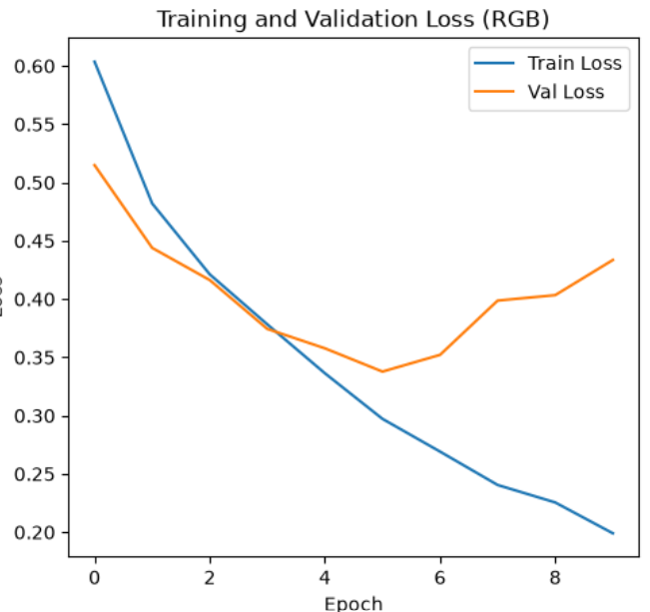
5. a. Paste here all screenshots/figures of the tuned model
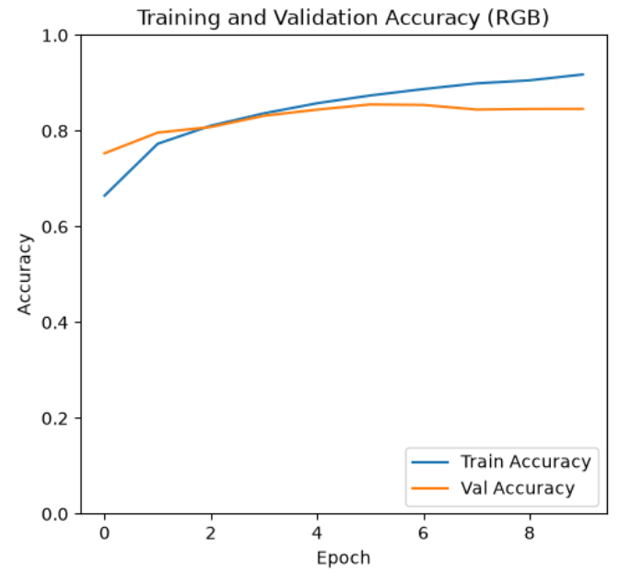

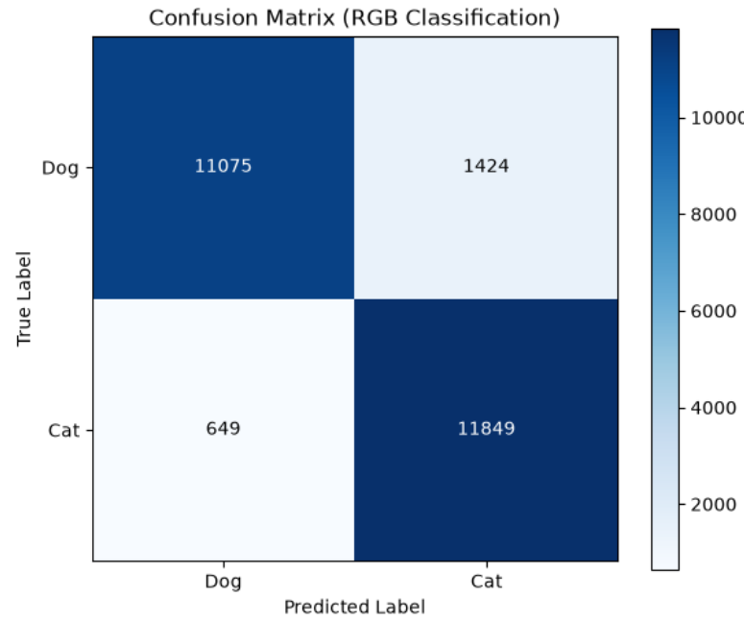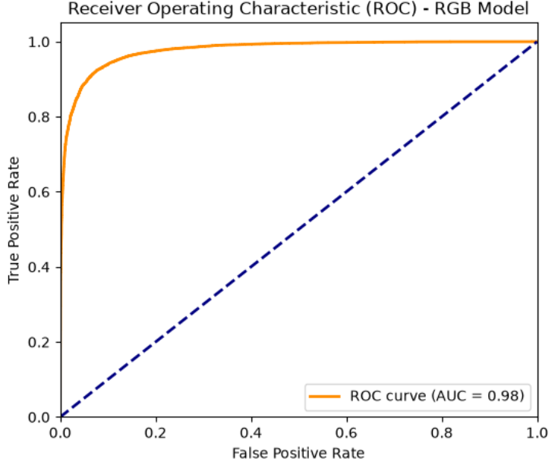

6. Overall Justification / Remarks
Summarize why this combination of hyperparameters was chosen (e.g., prior trial results, literature basis, computational constraints) and any observations (overfitting, underfitting, convergence issues).

